PSO Note

Swarm intelligence 5 principles：-群体具有自主性；反应性；学习性；自适应性etc

1. Proximity Principle: 群体能够进行简单的空间&时间计算
2. Quality Principle： 群体能够响应环境中的品质因子
3. Principle of Diverse Response： 群体的行动范围不应该太窄
4. Stability Principle： 群体不应该在每次环境变化时都改变自身行为
5. Adaptability Principle： 在代价不太高的情况下群体能够在适当的时候改变自身行为

Swarm intelligence 特点：

1. 控制是分布式的，不存在中心控制（no centralized control structure）;鲁棒性：不会犹豫某个或几个个体出现故障而影响群体对整个问题的求解
2. Stigmergy:群体中的每个个体都能够改变环境，这是个体之间间接通信得一种方式
3. 群体每个个体的能力或遵循的行为规则非常简单-实现方便
4. Emergent Intelligence：群体表现出来的复杂性为是通过简单个体的交互。。。。

Artificial Intelligence三流派：物质（蛋白质）/符号/亚符号（信号）

1. Symbolism: 符号
2. Behaviorism ：协调机制-e.g.: Swarm intelligence
3. Connectionism

Artificial intelligence design 3原则：

1. 简单，简单，便于实现，更可靠
2. 无状态，所保留状态不能再系统中长时间起作用，这就是使系统对于环境的变化和其他失误有更强的适应能力
3. 高冗余性，系统能与不确定因素共存

Swarm intelligence包括：

1. 蚁群算法（Ant Colony Optimization, ACO）
   1. 类似Traveling Salesman Problem TSP
   2. 蚂蚁经过路线留下pheromone； 根据pheromone的强度来指导方向； 物质强度越大；蚂蚁越倾向跑这条路；良性循环；整个蚁群最终会跑最短的路径
2. 微粒群优化算法（Particle Swarm Optimization，PSO）
   1. Bird flock
   2. 加入近邻的速度匹配、并考虑了多维搜索和根据距离的加速、惯性权重w
      1. 自适应（Adaptive PSO）版本
      2. 离散（discrete）版本
      3. Genetic Hybrid PSO(GPSO)
      4. Quantum-Behaved PSO(QPSO)
      5. Chaotic PSO(CPSO)

PSO 的应用（现存）10 groups：

1. Scheduling; (timetabling)
   1. Train routing
   2. maintenance plans
   3. power supply substations of electrified railway
   4. crane scheduling
   5. train crew scheduling
2. Active controls;
   1. achieve adaptive or semi-adaptive systems
   2. levitation process of maglev vehicles
   3. controller to achieve active pantograph control
   4. automatic train operation

3. Network layout;

4. Allocation;

5. Design;

* + a. train speed profile design,
  + b. vehicle design
  + c. system layout design

1. Forecasting;
   1. predict traffic volumes under different ticket price
2. Train controls;( Railway domain)
   1. minimum energy consumption. Besides the energy objective, other objectives such as punctuality, stopping precision at the platforms, train safety, and passenger ride comfort
3. Fault diagnosis;
   1. railway traffic signaling systems Railway track circuit fault diagnosis (

vehicle systems, railway power supply substations and satellite train po)

1. Parameter determination;
   1. Crack models
   2. Hydrogen fuel cell models
   3. Rock creep models
   4. Track curvatures from measured data
2. Others.
   1. High-speed trains
   2. Minimization of supply chain costs
   3. Optimizations of the communication strategies of various systems in the train

Parallel PSO:

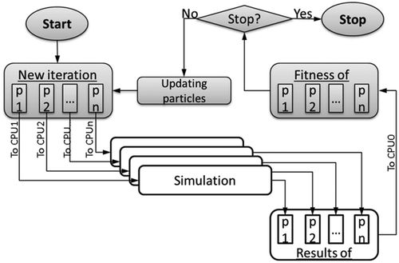

PSO 的component：

* Searching Space
* Particle:
  + position
  + velocity (difference of two position):
    - v1=p1-p2
* mathematical function(mapping)
  + v1\*x； x is the coefficiency
  + v1+v2
  + p3 = x(v1+V2)
* swarm/group (30-50)
* result: satisfactory solution
* Classes:
  + Position (x, y); 2-dimensional
  + Velocity (x, y); 本质也是个position
  + Particle (velocity, position, fitness)
  + SimplePSO: mainControl
    - initialSwarm();
    - execute();
  + PSOConstants:
    - Interface to define the parameters used in PSO
    - Store constants